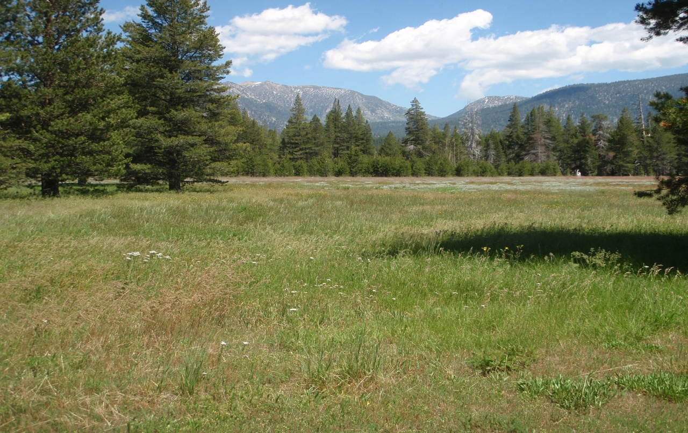
Washoe Meadows State Park

PARKS OR PROFITS?
California’s State Parks and Recreation Commission voted 5-0 to allow a golf course to be developed within Washoe Meadows State Park. To make the development legally possible, the commissioners downgraded the state park to a recreation area—setting a dangerous precedent that puts all state parks at risk.

The state purchased Washoe Meadows in 1984, citing the land’s outstanding ecological assets— rare fens, meadows, forests, wetlands, and cultural sites. The state park is home to a diversity of wildlife—Black bear, Pine marten, Coyote, birds, and fish, including Rainbow, Eastern Brook, and Brown trout. The park also provides a range of no-cost, family-friendly recreation—hiking, jogging, birding, and walking in nature. Nothing has changed since the park was established to justify removing it from the state parks system. But lobbyists for big business, including American Golf Corporation, owned by Goldman Sachs, have pushed officials to develop the park. Which state park will be next?

We are a diverse group of parks advocates, environmental scientists, and conservationists. We support the goals of The Upper Truckee River Restoration Project but not the State Parks’ preferred plan (Alternative 2), which requires relocating nearly half of the Lake Tahoe Golf Course to the Washoe Meadows State Park. We believe this plan would spread the damage the river restoration project seeks to limit, and sacrifice significant and sensitive areas of the family-friendly park to a single use—golf.
We support the less damaging alternative (Alternative 3), which would restore the river, improve the golf course where it is now, and keep Washoe Meadows—and potentially other state parks—intact for future generations.

The Tahoe Regional Planning Agency will decide whether to protect or develop the park.
Let them know you want Washoe Meadows—and all state parks—protected from development. To learn more: www.washoemeadowscommunity.org

